CHAPTER 8
MOMENTUM, IMPULSE, AND COLLISIONS
Discussion Questions
Q8.1 A heavy hammer is more effective. At the same speed the heavy hammer has more momentum and requires more force to stop it.

Q8.2 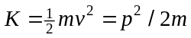. If it has the same momentum, the more massive bowling ball has less kinetic energy. Or, 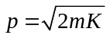 so if they have the same kinetic energy, the bowling ball has more momentum. The momentum of an object determines the force required to stop it, so it would be easier to catch a bowling ball at the same momentum.

Q8.3 For either a raindrop or apple, you can consider the object and earth together as an isolated system and say that the momentum of the object is transferred to the earth. Or, considering only the object as the system you can say that the net external force the ground applies to the object removes its momentum.

Q8.4 Kinetic energy depends only on speed but momentum is a vector and has the same direction as the velocity. The momentum of the car is different in the two cases.

Q8.5 The velocity of the truck relative to the fence post is different from its velocity relative to the police car, so the momentum of the truck is different in these two frames. Both frames are inertial frames so Eq.(8.3) applies and 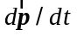 is the same in both frames.

Q8.6 (a) For a single object 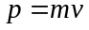 and 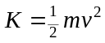. The kinetic energy is 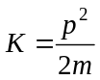. If 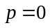 then 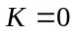. (b) The total momentum 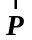 of the pair of objects is the vector sum of the individual momenta: 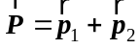. The total kinetic energy is the scalar sum 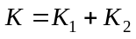. can be zero without 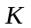being zero. An example is two objects that have momenta of equal magnitudes but opposite directions. The vector sum 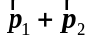 is zero but 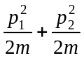 is not zero. The kinetic energy of an object does not depend on the direction of the velocity and it is never negative. (b) Yes. 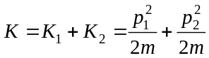. Both terms are positive so the only way can be zero is for 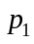 and 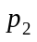 to both be zero, when both objects are at rest.

Q8.7 Momentum is not conserved, because of the net upward force exerted on the system by the ice as the rock is being thrown. The initial momentum is zero and after the rock is thrown the system has an upward component of momentum. The earth must be included in the system to have an isolated system for which momentum is conserved. There is no external force in the horizontal direction, so the horizontal component of momentum is conserved. The final horizontal component of the total momentum of the system is zero; the woman gains horizontal momentum in one direction and the rock gains an equal magnitude of horizontal momentum in the opposite direction.

Q8.8 Inelastic means 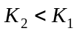. In a collision of two objects, if they stick together the collision must be inelastic. Such a collision is sometimes called totally inelastic. If the objects don’t stick together the forces during the collision can still do nonconservative work and the collision can be inelastic, with . In Example 8.5, 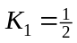(0.50 kg)(2.0 m/s) + (0.30 kg)(2.0 m/s) = 1.6 J and 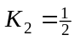(0.50 kg)(0.40 m/s) + (0.30 kg)(2.0 m/s) = 0.64 J. and the collision is inelastic.

Q8.9 The final kinetic energy would be zero if the final speed of the combined object is zero. This will be the case whenever the initial momentum of the system is zero, when 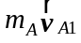 + 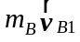 = 0. The initial kinetic energy is 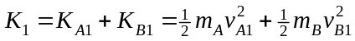 and cannot be zero. In the inelastic collision, momentum is conserved but kinetic energy is not.

Q8.10 The equation 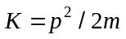 applies only to each object in the system. The kinetic energy 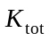 of the system is not equal to 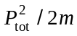, where 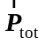 is the total momentum of the system. The vector sum 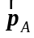 + 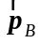 can be constant while the scalar sum 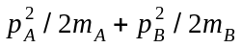 is not constant.

Q8.11 Define the relative velocity vector to be = 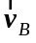 – 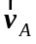.
Example 8.10: Only the -components of the velocities are nonzero.
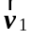 = 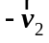; the relative velocity vector reverses direction.
Example 8.11: Only the -components of the velocities are nonzero.
= 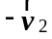; the relative velocity vector reverses direction.
Example 8.12: Both -components and -components of the velocities are nonzero.
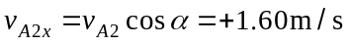; 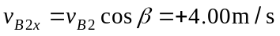
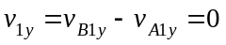
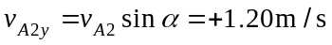; 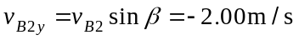
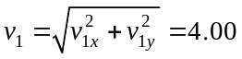 m/s; 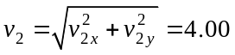 m/s
The magnitude of the relative velocity, before and after the collision is the same, but in this two-dimensional case the relative velocity vector does not simply reverse direction.
Q8.12 The hard collision with the concrete is of shorter duration so the maximum force is larger.
Q8.13 The Ping-Pong ball gains momentum in the 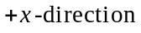and the bowling ball loses momentum in the , so that the total momentum of the system is conserved. Therefore, the bowling ball slows down a little and loses some kinetic energy. Kinetic energy is transferred from the bowling ball to the Ping-Pong ball and the total energy of the two balls is conserved.
Q8.14 The momentum change of the bullets is greater if they bounce off, so the average force on the plate is greater in that case.
Q8.15 For a constant force the change in momentum equals the impulse, the product of force and time. Half the force requires twice the time for the same impulse and momentum change; the 2 N force would need to act for 0.50 s.
Q8.16 There must be times when 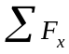 is positive and times when it is negative. The area under the positive part must equal the area under the negative part, so that the net impulse will be zero.
Q8.17 If the force exerted on the racket by the person’s hand while the ball and racket are in contact is neglected then the total momentum of the system is conserved. As the ball moves through the air it is acted on by the external force of gravity and this net external force changes its momentum.
Q8.18 Apply Eq.(8.31). After the rifle is fired,
.
The center of mass of the system maintains a constant velocity of zero during the firing. This agrees with Eq.(8.34); the net external force on the system is zero so the velocity of the center of mass is constant.
Q8.19 The momentum of the system egg plus earth remains constant. The egg acquires a downward momentum and the earth acquires an upward momentum of the same magnitude so that the total momentum of the system is zero. The mass of the earth is much, much larger than that of the egg so the upward velocity of the earth is very, very small.
Q8.20 No. With respect to horizontal motion she is an isolated system and her center of mass must remain at rest.
Q8.21 No. For both fragments to fall straight down each fragment would have zero horizontal component of momentum and the total momentum of the system would have zero horizontal component immediately after the explosion. But immediately before the explosion the velocity of the shell is horizontal and the horizontal component of its momentum is not zero. Momentum is conserved in the explosion so the horizontal component of the total momentum can’t be zero immediately after the explosion.

Q8.22 By Newton’s 3rd law the fragments exert forces of equal magnitudes on each other. By Newton’s 2nd law the same force produces a greater acceleration for the lighter fragment. The forces on each fragment act for the same time interval, so with a greater acceleration the lighter fragment acquires a greater final speed. In fact,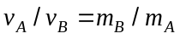. 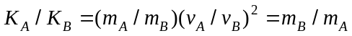. This same result is derived in Exercise 8.26 using conservation of linear momentum.

Q8.23 (a) False. As the apple falls it gains speed and its momentum increases because of the net force on it due to gravity. (b) True. No nonconservative forces act on the apple so its mechanical energy is conserved. Gravitational potential energy is converted to kinetic energy. (c) False. (d) False. It gains kinetic energy, because positive work is done on it by the net force on it, the gravity force.

Q8.24 (a) True. If it is assumed that no net external force acts on the clay during the collision, then the momentum of the system is conserved. (b) False. When objects stick together in a collision, the collision must be inelastic and kinetic energy is not conserved. Mechanical energy is not conserved because of the work done during the collision by the nonconservative forces that the pieces of clay exert on each other. This work converts some of the initial kinetic energy into thermal energy and energy of deformation. (c) False. (d) False.

Q8.25 Newton’s third law says that the magnitude of the force exerted on each mass is the same. These forces act for the same length of time, until the masses lose contact with the spring. Therefore, the magnitude of the impulse applied to each mass is the same. But the lighter mass moves a greater distance while they are in contact with the spring so more work is done on the lighter mass. (a) Equal magnitude of impulse means that the masses receive equal magnitudes of momentum. (b), (c) and (d). More work is done on the lighter mass so it gains more kinetic energy than the heavier mass. Or, . Equal momentum means greater kinetic energy for the lighter mass.

Q8.26 The magnitudes of momentum changes for the two vehicles are equal. By Newton’s third law, the force the SUV exerts on the compact car has the same magnitude as the force the compact car exerts on the SUV. But such a collision won’t be elastic and the kinetic energy of the system is not conserved and the kinetic energy changes for each object won’t be equal in magnitude. (a) False. (b) True. (c) False. (d) False.

